**Create Serverless Logic with Azure Functions SOP**

Create a Function App: a. Go to the Azure Portal. b. Select Create a resource, Compute > Function App. i. Resource Group: Select your Resource Group ii. Function App name: Unique Name iii. Publish: Code iv. Runtime Stack: PowerShell Core v. Region: Any

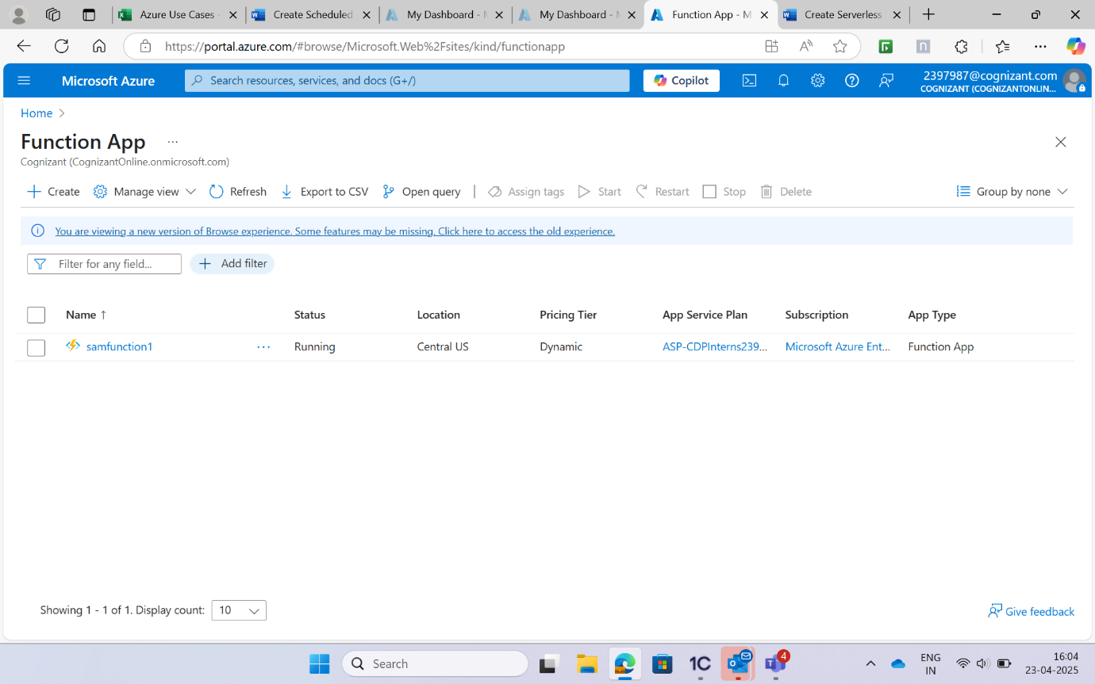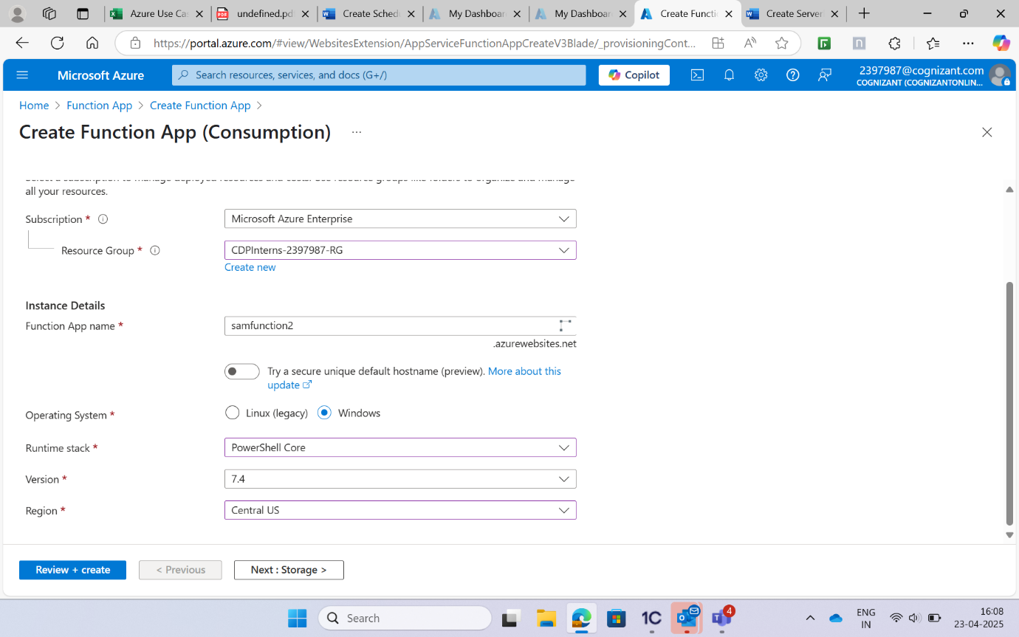a. Go to the Function App created by you. b. Go to the Functions blade and click on Add. c. Select HTTP Trigger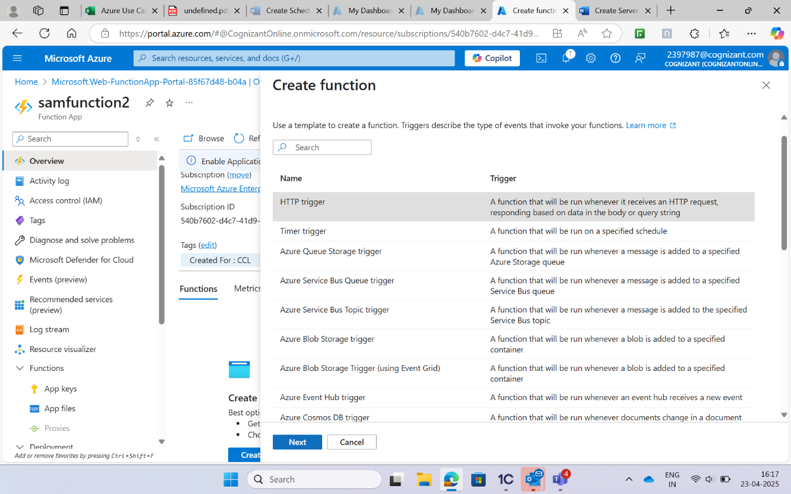Open the run.ps1 file and replace the contents with the following code. Make sure to save the file after updating it. Open the run.ps1 file and replace the contents with the following code. Make sure to save the file after updating it.